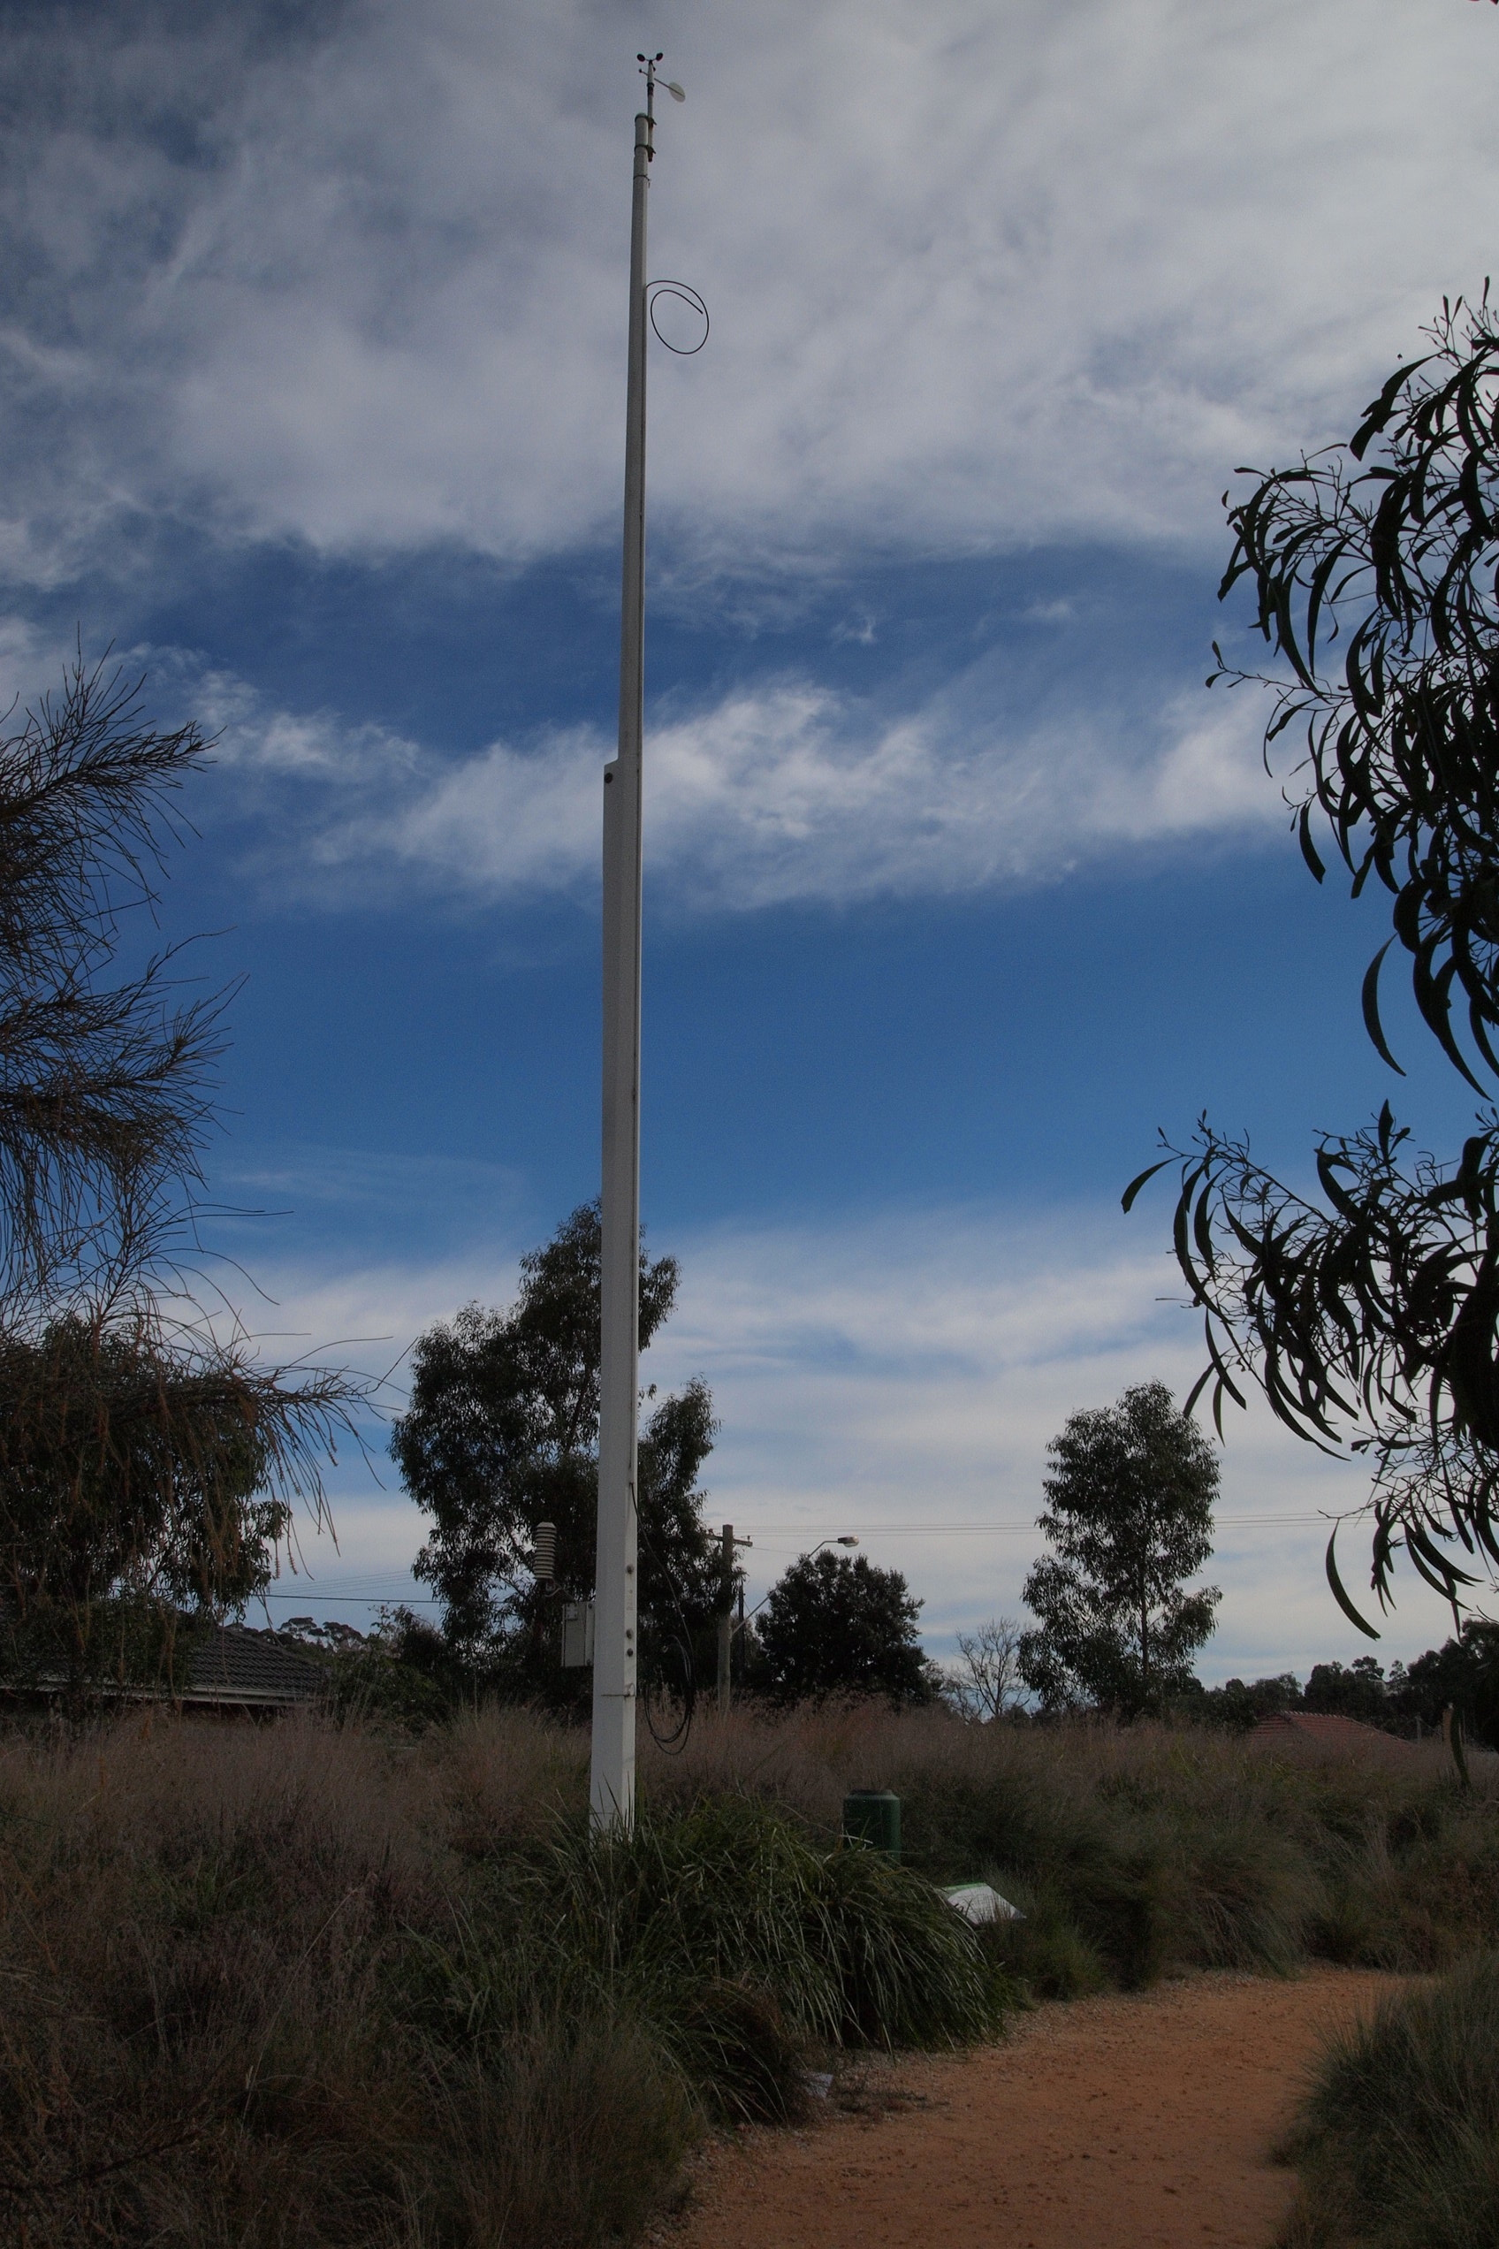**EXPLORING THE WEATHER WALL**

Aim: To read weather data collect by the Ecolinc Weather Wall and make observations.

Ecolinc is an environmental science centre situation in [Bacchus Marsh, Victoria](http://maps.google.com.au/maps?q=Bacchus+Marsh,+Victoria&hl=en&ll=-37.677299,144.440002&spn=1.604262,2.559814&sll=-25.335448,135.745076&sspn=56.685438,81.914063&z=9). Explore the [Ecolinc](http://www.ecolinc.vic.edu.au/) website.

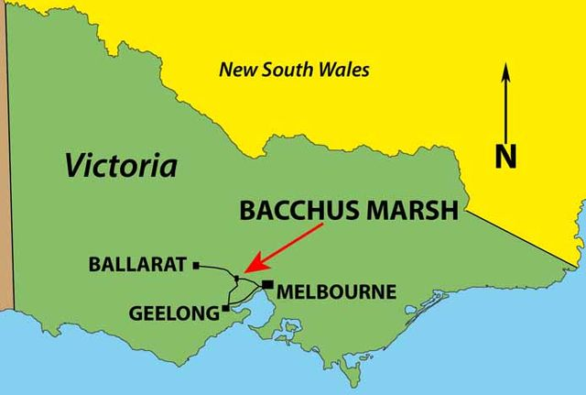

Ecolinc has a weather station designed by the CSIRO. The Ecolinc weather station records data about various weather parameters and this data is stored and displayed on the Ecolinc Weather Wall. In your journal explain what the [CSIRO](http://www.csiro.au/) does?

Complete the following activities and answer questions in your journal.

1. The following is a photo of the Ecolinc weather station. The Ecolinc weather station is located is located in an open position in the middle of the Ecolinc wetland and grassland ecosystem. The monitoring instrumentation is not influenced by local disturbance such as trees or buildings. Why might this be a problem?
2. This link provides individual photos of weather instruments. Identify and describe the weather instrumentation, which the station collects.
3. Follow this link [Ecolinc Weather Wall](http://202.76.157.2/weatherwallBMDB/wwallBMDB.html) and explore the current weather at Ecolinc. This link provides instructions for how to use the Ecolinc Weather Wall.
4. Describe the current weather (ensure you include the date and time of your observation).
5. Make observations about past weather data. Identify the weather conditions on your birthday and another date of significance (ensure you include the date and time of your observation).
6. Explore the ‘Interactive History’ feature and examine data collected throughout the day. Notice how wind direction, pressure, humidity, temperature and rainfall can vary. Make an observation.
7. The following weather elements should show interesting relationships. Find Ecolinc Weather Wall data to support the theory explanations.
8. Air pressure and rainfall - In general, low air pressure = precipitation, and high pressure = clear skies. Air pressure becomes lower because the air rises. In the process, the air cools down and produces condensation that will ultimately lead to rainfall.
9. Wind direction/speed and temperature. Consider the location of Bacchus Marsh in relation to the ocean. In general, air coming off the ocean is cool whereas air coming off the land is warm. In Bacchus Marsh’s case a north wind is warm and a southerly is cool.
10. Wind speed/direction and temperature. Wind chill is the felt air temperature on exposed skin due to wind. It measures the effect of wind on air temperature. When it is very cold the wind chill temperature is usually lower than the air temperature. When it is mild the wind chill temperature will be very close to the air temperature, if not the same.
11. Humidity and rainfall. Humidity is also known as relative humidity. The relative humidity maximum is 100%, which is means the air becomes saturated. If the air becomes saturated, condensation of the water occurs leading to a formation of tiny water droplets. Millions of such water droplets come together to form clouds. Under certain conditions such water droplets combine to form big rain drops which fall as precipitation due to gravity. Therefore, if the humidity is high, it leads to the formation of clouds and subsequent precipitation.
12. Observe ‘Mean Monthly Rainfall’ data. Provide explanations for the following:
13. In which month and year did Ecolinc experience the most amount of rain?
14. What time of year has the most rain? Is this what you would expect?
15. Open the following web page: [Monthly climate statistics - BOM - Melbourne](http://www.bom.gov.au/climate/averages/tables/cw_086071.shtml)

Ecolinc annual rainfall in 2009 = 352.6mm and in 2010 = 607.6mm. How does the annual rainfall at Ecolinc compare to Melbourne mean annual rainfall?

1. Bacchus Marsh is in a rain shadow, with warmer temperatures and a lower rainfall than Melbourne, Geelong and Ballarat. Bacchus Marsh mean annual rainfall is 505mm.

*In Victoria, the area around Port Phillip Bay is in the rain shadow of the Otway Ranges. The area between Geelong and Werribee is the driest part of southern Victoria; whereas the crest of Otway Ranges receives 2000mm of rain annually.*

Draw a picture to explain what is a rain shadow. [What is a rain shadow?](http://en.wikipedia.org/wiki/Rain_shadow)

1. This table shows the annual rainfall at Ecolinc.

|  |  |
| --- | --- |
| **Year** | **Ecolinc annual rainfall (mm)** |
| 2005 | 390 |
| 2006 | 354.8 |
| 2007 | 415 |
| 2008 | 303.8 |
| 2009 | 352.6 |
| 2010 | 607.6 |

Draw a line graph showing the annual Ecolinc rainfall using Excel or similar program.

1. ‘In 2010 Victoria recorded its wettest year since 1974 and the fifth wettest year on record, whilst Melbourne experienced its first year of above average rainfall since 1996’ (BOM Special Climate Statement Feb. 2011).

Does the data collected at Ecolinc and by the BOM support this observation?

1. Observe ‘Mean Temperature’ data. Provide explanations for the following:
2. Which months tend to be the warmest? Which months tend to be the coolest?
3. Is there a trend from year to year?