**WHEN TO PLANT OUT**

**Aim**

How does weather affect plants?

What is planting out? Planting out is the transfer of young healthy plants as seedlings from small pots into the soil. You will explore how weather conditions effect planting out.

1. In general, when you plant out it is optimal for soil to be warm (~18°C) and have a moist sub-soil (down to one foot). In general, which seasons would provide this environment?
2. Go to the [Ecolinc Weather Wall](http://202.76.157.2/weatherwallBMDB/wwallBMDB.html). Go to the annual rainfall data and answer the following question in your journal. Does Ecolinc have enough rain to provide perfect conditions for planting out?
3. Read the following scenarios. What would you do:
   1. It’s January. There has been a good amount of rain through December and January. Would you plant out?
   2. It’s September. There has been little rain through winter. Would you plant out?

Ecolinc is an ephemeral wetland.

1. Do some research to determine how an ephemeral wetland differs from a permanent water body?

Now your task is to determine the best location and time of year to plant out the following native Australian plants: River Red Gum, Kangaroo Grass, Water Plantain and Golden Wattle.

To determine when to plant out you must understand the following: all native plants will go through the same cycle.

You will examine the plant requirements for each plant profile below and:

1. Using appropriate symbols, complete the yearly plant calendar to show the flowering time, optimal time for seed collection and planting out, and
2. Plot the best location to plant out on the wetland map (choose an appropriate symbol for each plant).

PLANT PROFILE 1:

|  |  |
| --- | --- |
| Species name | *Eucalyptus camaldulensis* |
| Common name | **River Red Gum** |
| Description | Medium size tree (12-45m tall).  Patchy greyish ‘gum’ bark, thick trunk and heavy twisted branches.  Leaves: Long (9-20cm) and pale green. |
| Flowering | Flowers: A cluster of white (7-11 flowers).  Flowers from November to March. |
| Optimal seed collection | Seed collection is done from March to July, and September.  Woody capsules and seed is released when valves open slightly when mature. |
| Optimal germination | Optimal germination temperature: up to 30°C. |
| Planting out | Mid-spring |
| Habitat requirements | Plains grasslands  Riparian scrub  Woodlands |

River Red Gum features and locality video

PLANT PROFILE 2:



|  |  |
| --- | --- |
| Species name | *Themeda triandra* |
| Common name | **Kangaroo Grass** |
| Description | Fine, deep rooted tussock-forming grass.  Leaves: Soft, linear leaves to 30cm. |
| Flowering | Flower heads on slender stems to 1m.  Flowers usually from September to February. |
| Optimal seed collection | Seed collection is done from December to February.  Seeds are contained in seed-heads that rise above the plants on tall stems. Each has a twisted awn. |
| Optimal germination | Occurs in spring when soil moisture is high and soil temperature is about 20°C. |
| Planting out | Mid-spring |
| Habitat requirements | Plains grasslands  Red gum and box woodlands  Grassy wetlands  Grassy open low forest  Dry valley sclerophyll forest |

Kangaroo Grass features and locality video



PLANT PROFILE 3:

|  |  |
| --- | --- |
| Species name | *Alisma planatgo-aquatica* |
| Common name | **Water Plantain** |
| Description | Large aquatic plant (1.5m tall).  Leaves: Erect spear shaped leaves up to 50cm on a long predominant stalk. |
| Flowering | Flowers: Dainty white flowers on stalks up to 1m high.  Flowers open for a day then shrivel.  Flowers from mid to late December to January. |
| Optimal seed collection | Seed collection is done from late November to early January.  Seeds are borne on ends of old flower heads. They turn tan and fall from plant when ripe. Remove seeds by hand or cut flower stalk for collection. |
| Optimal germination | Germinate in shallow water on waterlogged mud (“Bog Method”). |
| Planting out | Mid-spring |
| Habitat requirements | Grows in moist soil and shallow water.  Aquatic, in riparian scrub and grassy wetlands. |

Water Plantain features and locality videos



PLANT PROFILE 4:

|  |  |
| --- | --- |
| Species name | *Acacia pycnantha* |
| Common name | **Golden Wattle** |
| Description | Shrub/small tree (2-8m tall).  Bark: Smooth, dark brown to grey bark.  Leaves: The mature plant does not have true leaves but instead has leaf-like flattened stems called phyllodes.  Australia’s floral emblem. |
| Flowering | Flowers: Fragrant, fluffy golden rounded flower heads.  Flowers from August to October. |
| Optimal seed collection | Seed collection is done from December to early January.  Pods: Flattish almost straight. Seeds are enclosed in pods. As seed matured the pods change from green to shades of brown. Pods contain 3-8 seeds that go dark brown to black. Seeds usually drop to the grounds soon after maturity in warmer weather. If seed pods are collected, they should be placed in direct sun on a hot day to fully open. |
| Optimal germination | Seed must be treated for germination. Pre-treatment includes soaking in boiling water or by scarification. |
| Planting out | Mid-spring |
| Habitat requirements | Dry to damp valley sclerophyll forests  Plains woodlands  Red gum woodlands |

Golden Wattle features and locality video



|  |  |  |  |  |  |  |  |  |  |  |  |  |
| --- | --- | --- | --- | --- | --- | --- | --- | --- | --- | --- | --- | --- |
|  | JAN | FEB | MAR | APR | MAY | JUN | JUL | AUG | SEP | OCT | NOV | DEC |
| PLANT 1 |  |  |  |  |  |  |  |  |  |  |  |  |
| PLANT 2 |  |  |  |  |  |  |  |  |  |  |  |  |
| PLANT 3 |  |  |  |  |  |  |  |  |  |  |  |  |
| PLANT 4 |  |  |  |  |  |  |  |  |  |  |  |  |

**YEARLY PLANT CALENDAR**

Key

F Flowering time

S Optimal seed collection

P Planting out

Based on your calendar, in your journal answer the following:

1. Identify typical trends between plant species throughout the year.
2. When does planting out occur and why?

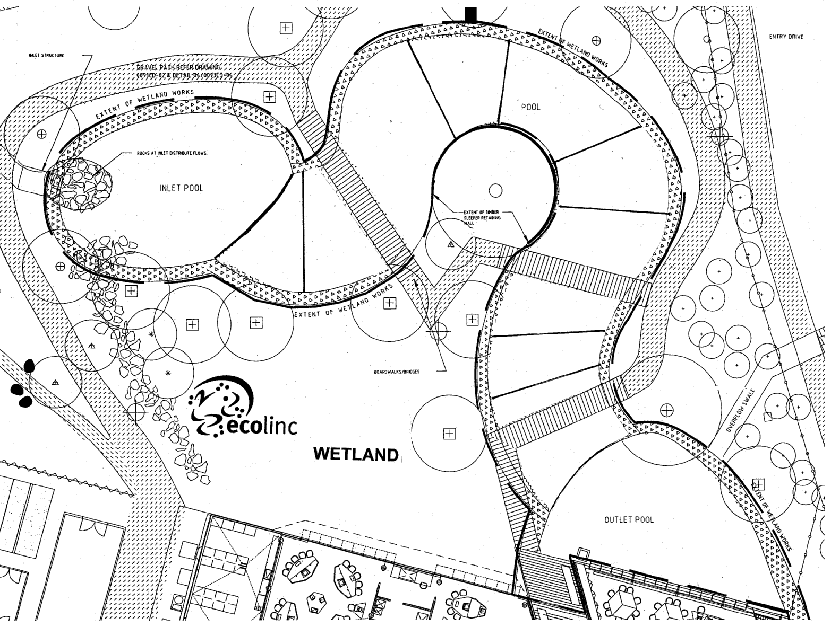

**SYMBOL PLANT**

River Red Gum

Kangaroo Grass

Golden Wattle

Water Plantain